KENDRIYA VIDYALAYA PORBANDAR
WINTER BREAK HOLIDAY HOMEWORK
Subject: English Class: VII
Q.1Direct And Indirect Speech Exercise
1.My friend said, “Mr Shah writes short stories.”
2) The boys said, “ They sing good prayers.”
3) My teacher Said, “Anika is knitting a sock.”
4) Rahul said , “The old man is selling roses”.
5)The dealer said, “People have demanded much profit.”
6) The teacher said, “The students have not written full answer.”
7) She said, “ The children have drawn good pictures.”
8) She said, “Krishna sang a song.”
9)Mr.sharm said,” He sold his TV.”
10) Vandana said, “Pihu was in the laboratory.”
Q.2 You are Atul Sharma, the Secretary of Maya Nagar Welfare Society, Kanpur. Write a letter to the Chairman, Kanpur Electricity Supply Board, complaining about frequent power failure in area.
Q.3 Create a short story in about 80 words with a moral and a heading.
Q.4
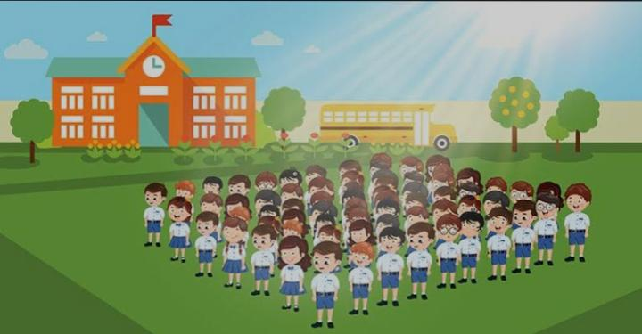
Look at the above picture and compose sentences for Paragraph on the morning assembly in the school with the help of the following clues:

-Morning assembly on the prayer ground – Time 8.50a.m.-at second bell-all students gathered on the prayer -ground -in queues class wise – teachers and principal also on one side.
Q.5Read all the lessons that you have studied till the month of December at least twice and Underline the difficult words with pencil. ( You can expect PT 2 Exams in January. So make sure that you revise all the lessons properly.)
Q.6TOPIC : Poem of your choice.( from your text)
- Write a brief summary.
- Write about the poet.
- Central idea of the poem.
- The message you get from the poem. Support with necessary pictures & drawings.

